Use Case Scenerios
For Health Benefits Exchange (HBE)

Prepared by:
Prepared for:
Date submitted:
Filename: | 0000.doc
Document Number
Last Edit: | 5/28/2013 06:15:00 PM by
Comments:

Table of Contents
Section Zero: Description 4
Section One: Actors 5
Section Two: Admin Use Cases 6
Section 2.1 – AM-001 Create Individual Account 6
Section 2.2 – AM-002 Create Employer Account 6
Section 2.3 – AM-003 Create Broker Account 7
Section 2.4 – AM-004 Create Navigator Entity / Navigator Account 7
Section Three: Broker Use Cases - 9
Section 6.1 – FM-001 Carrier Free Billing 9
Section 6.2 – FM-002 Provide Payment 9
Section Four: Eligibility Use Cases 10
Section 6.1 – FM-001 Carrier Free Billing 10
Section 6.2 – FM-002 Provide Payment 10
Section Five: Enrollment Use Cases 11
Section Six: Financial Management Use Cases 12
Section 6.1 – FM-001 Carrier Free Billing 12
Section 6.2 – FM-002 Provide Payment 12
Section Seven: Individual Use Cases 13
Section 7.1 – IN-001 Process Offline Correspondence 13
Section Eight: Small Business Use Cases 14
Section 8.1 – PS-001 Shop For Employer Plan Use Cases 14
Section 8.2 – 14
Section 8.3 – 14
Section 8.4 – 14
Section Nine: 15
Section 9.1 – Sponsors and Stakeholders 15
Section 9.2 – Primary Users 15
Section 9.3 – Secondary Users 15
Section Ten: 16
Section Eleven: 17
Section Twelve: 18
Section Thirteen: 19
Section 13.1 – Operational Environment 19
Section 13.2 – User Interface Requirements 19
Section 13.3 – User Access / Security Requirements 19
Section Fourteen: 20
Section 14.1 – Assumptions 20
Section Fifteen: Risks and Risk Management Process 21

Section Zero: Description

Section One: Actors
Term | Definition
Individual | An individual that will enter the Exchange to create an individual account.
Employee | An employee will enter the Exchange to create an individual account.
Broker | A Broker will access the Exchange to create their account.  Brokers logging into their broker account will have the ability to create an individual account on behalf of their customer.
Navigator Entity | A Navigator Entity will create accounts for Navigators in their agency.
Exchange | The Exchange will track and store account information for users of the Exchange.  The Exchange will also send notices as appropriate.
Employer | An employer will enter the Exchange to create an employer account.
Customer Service Representative | Customer Service Representative will create Navigator Entity Accounts and notify the Entity of the account creation.  Customer Service Representative will create Carrier Accounts based on the Carrier requesting an account.
Carrier Portal | The Carrier Portal will be used to create the Carrier Account.
Carrier | The Carrier provides the information needed to have an account created on their behalf.
User | A user may be an individual, an employee, an employer, a broker, a navigator entity, or a navigator.

Section Two: Admin Use Cases

Section 2.1 – AM-001 Create Individual Account
This Use Case is used to create an individual account to log into the Exchange for Enrollment. The Use Case completes successfully when the account is created and an individual has a unique user ID and password to log into the Exchange.
An individual must have an account in order to access the Individual Exchange. Authorized users may also create accounts on behalf of individuals and employees. When submitted, the system is checked to see if an account for the individual already exists in the Exchange. If not, the account is created. If so, the individual is prompted to login user credentials. If the Individual’s Credentials are unknown, the user may click on “Forgot Password” or “Forgot Log In”. The system then proceeds to Manage Password Use Case _____.
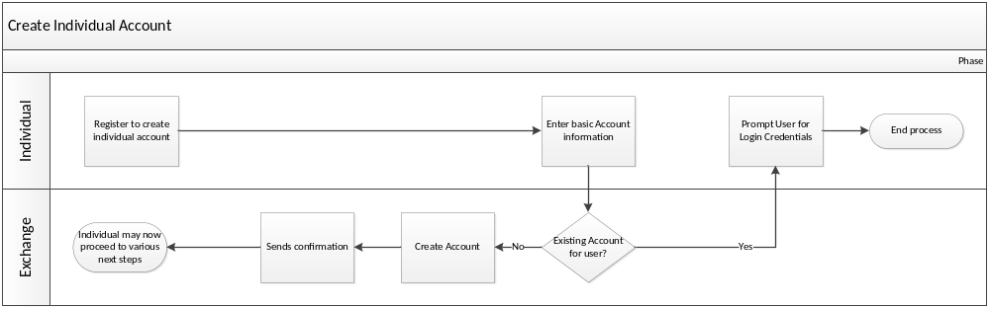

Section 2.2 – AM-002 Create Employer Account
This Use Case is used to create an Employer Account to log into the Small Business (SB) Exchange. The Use Case completes successfully when the account is created and the employer has a unique user ID and password to log into the Exchange.
An employer must have an account in order to access features in the SB Exchange. In order to setup employer sponsored plans or to manger their employee roster. Authorized actors may also create accounts on behalf of employers. When submitted, the system checks if an account already exists in the Exchange for the business. If no existing account is found, an account is created. If the system does find an existing account, the Exchange prompts the user for login credentials. If the Employer’s Credentials are unknown, the user may click on “Forgot Password” or “Forgot Log In”. The system then proceeds to Manage Password Use Case _____.

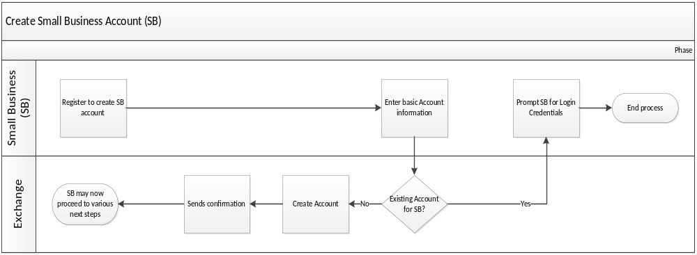

Section 2.3 – AM-003 Create Broker Account
This Use Case is used to create a Broker Account to log into the Exchange. The Use Case completes successfully when the account is created and the broker has a unique broker user ID and password to log into the Exchange.
A broker account must be established to allow access to manage customers, plans, applications, and proposals on the Exchange. After the actor navigates to the register screen in the Broker Portal, basic information is entered to create an account. When submitted, the system checks to see if an account for the broker already exists in the Exchange system. If no existing account is found, the account is created and an electronic notification is sent to the broker. If an account is found, the user will be prompted for login credentials. If the Broker’s Credentials are unknown, the user may click on “Forgot Password” or “Forgot Log In”. The system then proceeds to Manage Password Use Case _____.
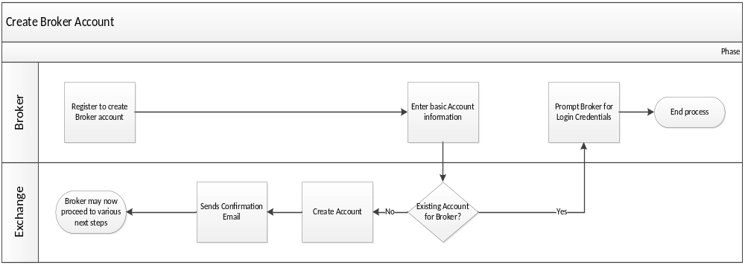

Section 2.4 – AM-004 Create Navigator Entity / Navigator Account
This Use Case is used to create a Navigator Entity Account and to create Navigator Accounts. When created, the Entity or Navigator can log into the Exchange. The Use Case completes successfully when the Entity and Navigator Accounts are created and the Entity or Navigator has a User ID and password to log into the Exchange Navigator Entity Portal.
The Customer Service Representative will create the Navigator Entity Account with an Entity ID (unique log in ID) and defaulted password. The Entity is notified of their account creation. An administrator at the Entity agency will log into the Exchange using this account information. The Entity Administrator will then create Navigator Accounts for their workers. The Navigator ID (unique log in ID) will be assigned by the Entity and a default password given, which will need to be reset by the Navigator after their first log-on. The Navigator will be sent an email notice that the account has been created.
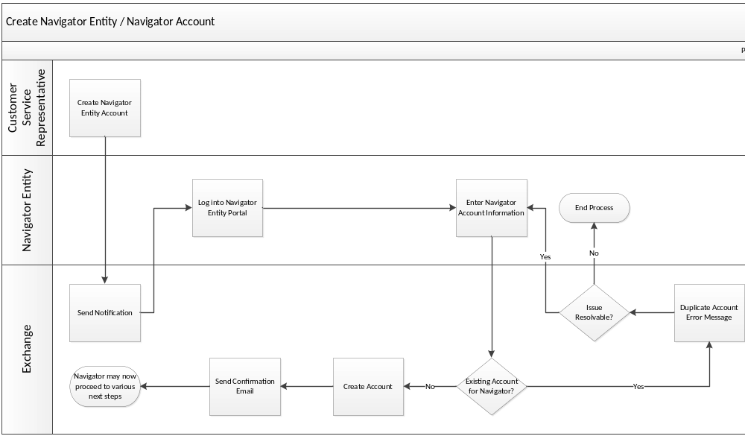

Section 2.5 – AM-005 Create Carrier Account
This Use Case is used to create a Carrier account to log into the Carrier Portal to Certify the Carrier and load Carrier plans. The Use Case completes successfully when the account is created and the Carrier has a unique user ID and password to log into the Carrier Portal.
A Carrier account must be established to allow access to get certified and allow the Carrier to load plans through SERFF to the Carrier Portal. Customer Service Representative will create an account on behalf of the Carrier. This will be done by entering the required data to create the carrier’s account. A validation step will be done to confirm there is not an existing account. If no existing account is found, the account will be created and a notification will be sent to the Carrier.
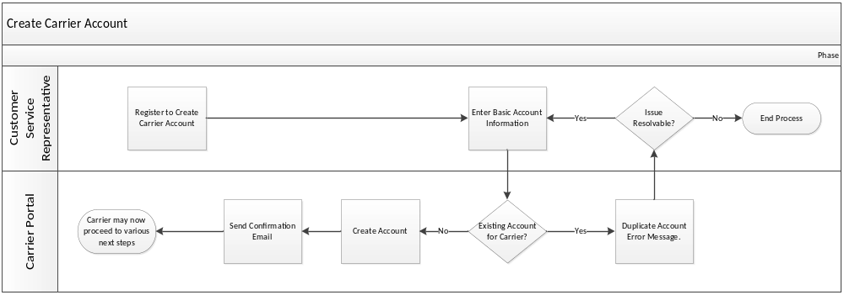

Section 2.6 – AM-006 Create Customer Service Representative Account
This Use Case is used to create a Customer Service Representative Account to log into the Exchange. The Use Case completes successfully when the account is created and the Customer Service Representative has a unique user ID and password to log into the Exchange.
A Customer Service Representative account must be established to allow ___________.

Section 2.7 – AM-007 Manage Password

This Use Case is used to manage all aspects of the Password process in the Exchange for any and all Actors that will be using The Exchange in any way. The Use Case completes successfully when an actor is able to log in to the Exchange with the proper password and use the Exchange.

Section Three: Broker Use Cases -

Section 6.1 – FM-001 Carrier Fee Billing

Section 6.2 – FM-002 Provide Payment

Section Four: Eligibility Use Cases

Section 6.1 – FM-001 Carrier Free Billing

Section 6.2 – FM-002 Provide Payment

Section Five: Enrollment Use Cases

Section Six: Financial Management Use Cases

Section 6.1 – FM-001 Carrier Free Billing

Section 6.2 – FM-002 Provide Payment

Section Seven: Individual Use Cases

Section 7.1 – IN-001 Process Offline Correspondence

Section Eight: Small Business Use Cases

Section 8.1 – PS-001 Shop For Employer Plan Use Cases

Section 8.2 –

Section 8.3 –

Section 8.4 –

Section Nine:

Section 9.1 – Sponsors and Stakeholders

Section 9.2 – Primary Users

Section 9.3 – Secondary Users

Section Ten:

Section Eleven:

Section Twelve:

Section Thirteen:

Section 13.1 – Operational Environment

Section 13.2 – User Interface Requirements

Section 13.3 – User Access / Security Requirements

Section Fourteen:

Section 14.1 – Assumptions

Section Fifteen: Risks and Risk Management Process

